
2026 EQUIPMENT RENTAL RATES
Rates Effective February 1, 2026

Trax Boom Lift Day $350 Week $1100
2 Weeks $1600 3 Weeks $2100
Month $2500

Wheeled Boom Lift Day $300 Week $1000
2 Weeks $1500 3 Weeks $2000
Month $2400

Telehandler or Scissor Lift Day $300 Week $1000
2 Weeks $1500 3 Weeks $2000
Month $2400
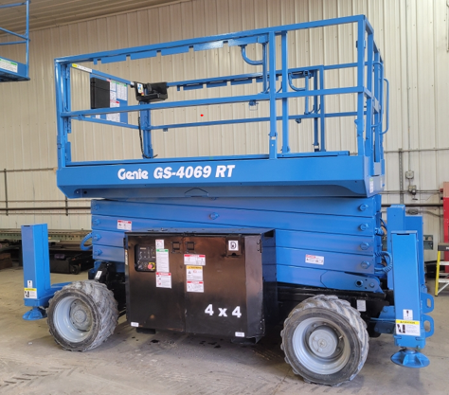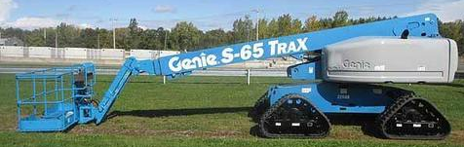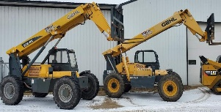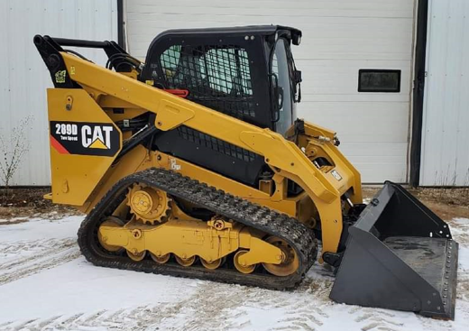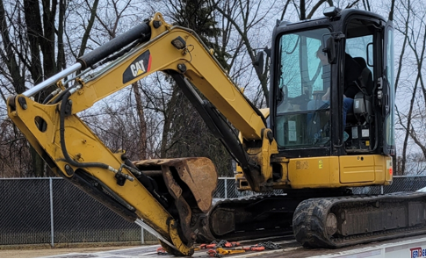
Indoor Scissor Lift Day $50
Week $200
Month $700

Mini Excavator Day $500
Week $1500
Month $3000

Skid Loader Day $350 Week $1100
2 Weeks $1600 3 Weeks $2100
Month $2500
Skid Loader Attachments Available – Root Grapple Bucket, Auger Drive 12” & 24” bit, Hydraulic Forks

Rental rates do NOT include Delivery / Removal Fees and Fuel.
All equipment must be fueled prior to removal.
Shop Labor Rate $150 an hour.

